**OOPs**  
  
1. Abstraction

Abstraction hides the implementation details and exposes only the essential features of an object. This is achieved using **abstract classes** or **interfaces**.

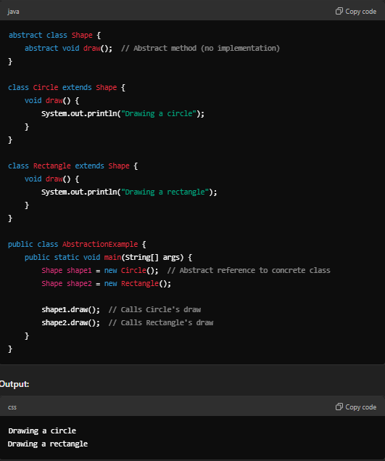

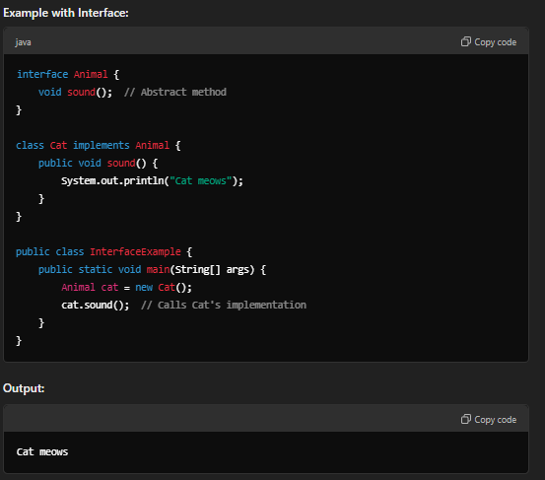

2. Polymorphism

Polymorphism allows objects to take multiple forms. It enables one interface to be used for different data types or methods. There are two types:

* **Compile-time polymorphism** (method overloading)
* **Runtime polymorphism** (method overriding)

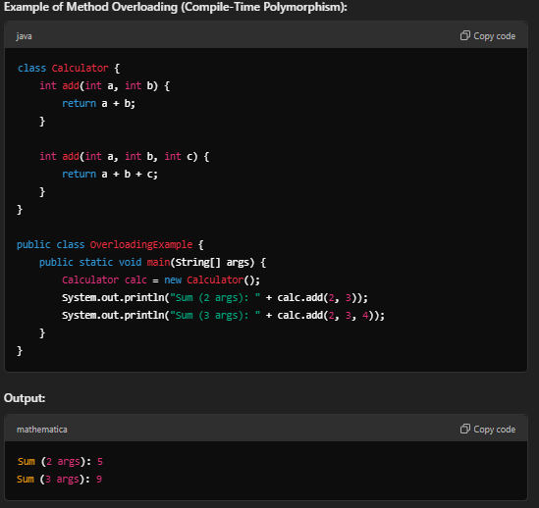

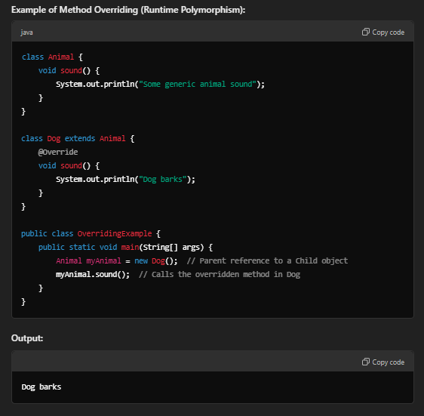

3. Inheritance

Inheritance allows a class (**child class**) to inherit fields and methods from another class (**parent class**), enabling code reuse and hierarchical relationships.

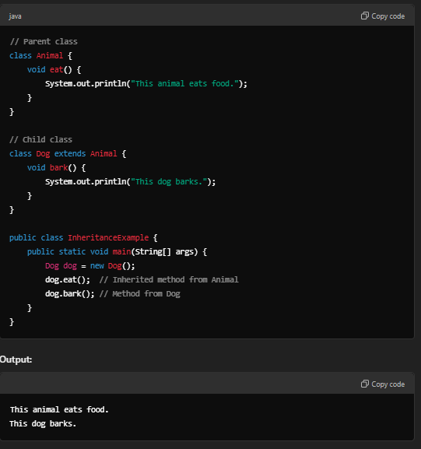

4. Encapsulation

Encapsulation is the bundling of data (fields) and methods (functions) into a single unit called a **class**. It restricts direct access to the internal details of an object and protects the integrity of the data by using **getters and setters**.

